SIMATS ENGINEERING
ASSESSMENT TOOL 1

COURSE NAME: MLA03
COURSE CODE: Reinforcement learning

COURSE OUTCOME COVERED
CO1: Analyze reinforcement learning frameworks and Markov Decision Process
concepts to model decision-making problems. (BL2, BL3)
Assessment Tool Weightage: 50%
Dr. G. A. Senthil
QUESTIONS: 10 Total Marks: 50

Annexure A

RL Basic Experiments demo with Keras and TensorFlow using Anaconda

navigator
Duration: 2hrs
Code of Conduct:
I S.Mani Sai(192425385) (Name / Reg No) certify that this submission is my original work
and that I have adhered to the guidelines specified for this assessment.
I understand that any violation of academic integrity rules will result in disciplinary action.
Signature of the student: Manisai.s

Experiment 1: Installation of Reinforcement Learning Development
Environment
Aim: To install and configure Anaconda Navigator, Python, TensorFlow, Keras,
Gymnasium (OpenAI Gym), NumPy, Matplotlib, and other required libraries, and
verify the environment by executing a simple Reinforcement Learning program.
- import gymnasium as gym
import numpy as np
import matplotlib.pyplot as plt

# Create CartPole Environment
env = gym.make("CartPole-v1", render_mode="human")

# Reset the environment
observation, info = env.reset()

print("Initial Observation:")
print(observation)

# Run for 100 steps
for step in range(100):
# Select a random action
action = env.action_space.sample()

# Perform the action
observation, reward, terminated, truncated, info = env.step(action)

print(f"Step: {step+1}")
print("Action:", action)
print("Observation:", observation)
print("Reward:", reward)

# Reset if episode ends
if terminated or truncated:
print("Episode Finished. Resetting Environment...\n")
observation, info = env.reset()

# Close the environment
env.close()

print("Reinforcement Learning Environment Verified Successfully!")
OUTPUT :
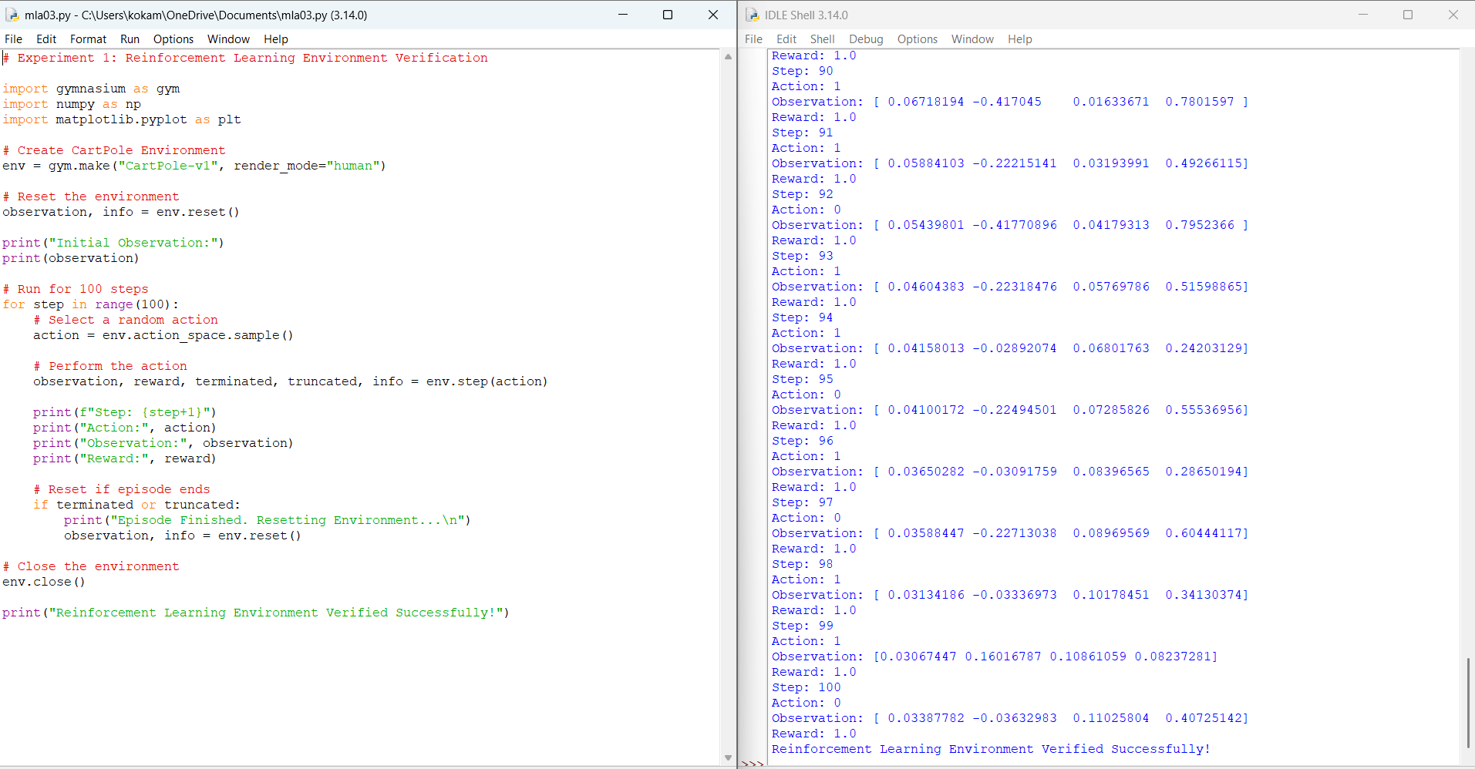

Experiment 2: Familiarization with OpenAI Gym/Gymnasium Environments
Aim: To create, initialize, and interact with standard Reinforcement Learning
environments such as FrozenLake, CartPole, and MountainCar using Gymnasium to
understand the concepts of states, actions, rewards, and episodes.
A. # Experiment 2
# Aim: Create and interact with FrozenLake, CartPole, and MountainCar environments

import gymnasium as gym

# List of environments
environments = ["FrozenLake-v1", "CartPole-v1", "MountainCar-v0"]

for env_name in environments:

print("\n" + "="*50)
print("Environment:", env_name)
print("="*50)

# Create Environment
env = gym.make(env_name)

# Reset Environment
state, info = env.reset()

print("Initial State:", state)
print("Action Space:", env.action_space)
print("Observation Space:", env.observation_space)

# Perform 5 random actions
for step in range(5):

action = env.action_space.sample()

next_state, reward, terminated, truncated, info = env.step(action)

print(f"\nStep {step+1}")
print("Action Taken :", action)
print("Next State :", next_state)
print("Reward :", reward)
print("Terminated :", terminated)
print("Truncated :", truncated)

if terminated or truncated:
print("Episode Finished")
state, info = env.reset()

env.close()

print("\nAll environments executed successfully.")
OUTPUT;
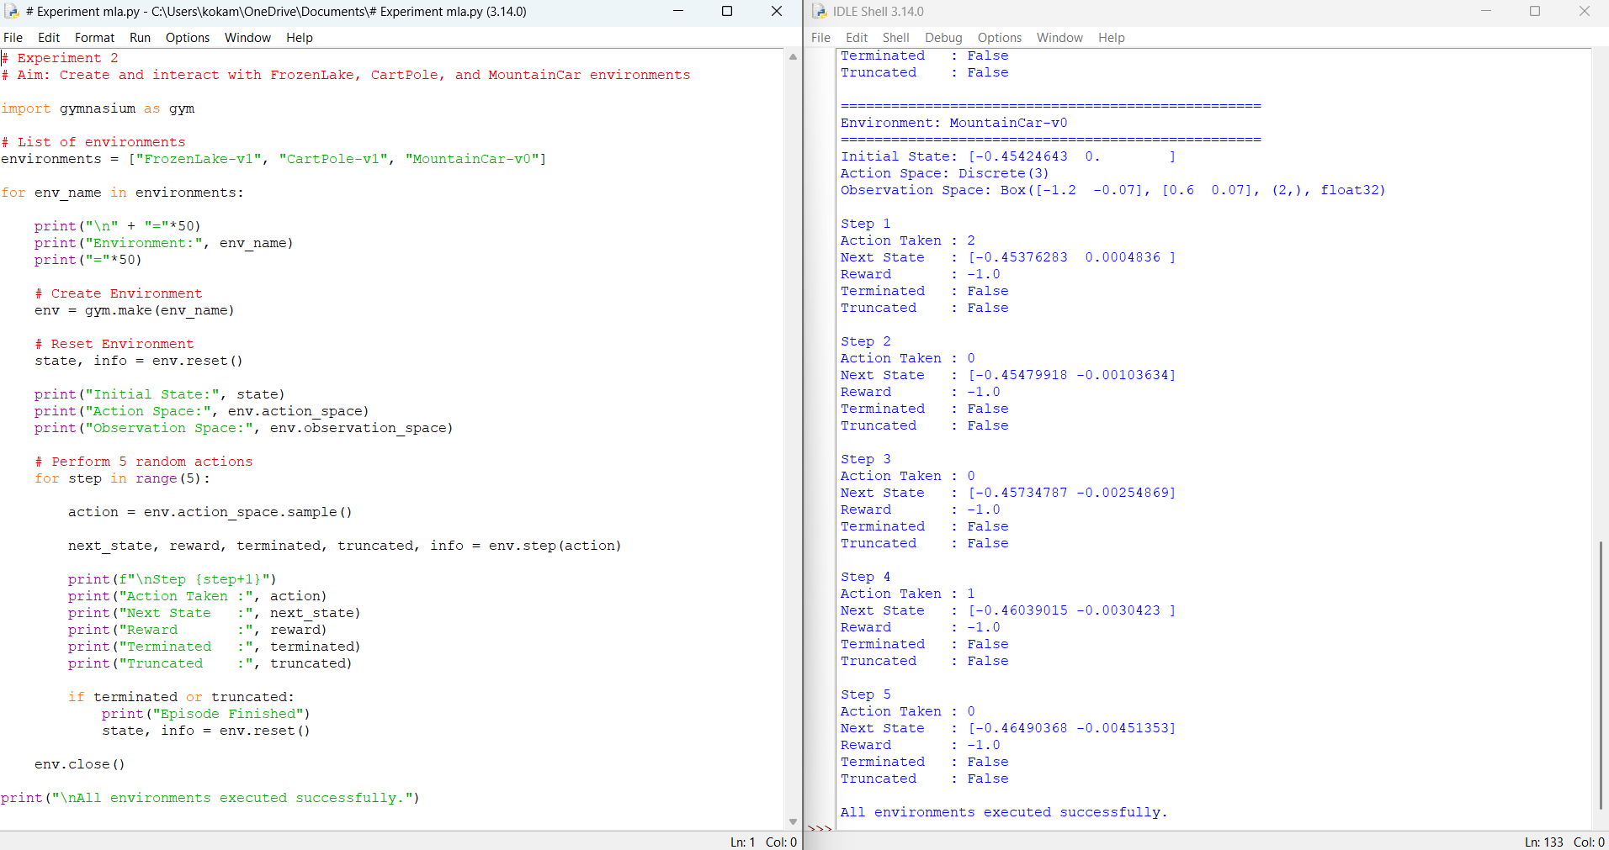

Experiment 3: Implementation of the Reinforcement Learning Framework
Aim: To implement the basic Reinforcement Learning framework by designing an
agent that interacts with an environment through states, actions, rewards, and
policies using Python.
A. import gymnasium as gym

# Create FrozenLake environment
env = gym.make("FrozenLake-v1", is_slippery=False)

# Reset the environment
state, info = env.reset()

print("Initial State:", state)

total_reward = 0

# Run one episode
for step in range(20):

# Random Policy
action = env.action_space.sample()

# Take action
next_state, reward, terminated, truncated, info = env.step(action)

print("--------------------------------")
print("Step:", step + 1)
print("Current State :", state)
print("Action Taken :", action)
print("Next State :", next_state)
print("Reward :", reward)

total_reward += reward

state = next_state

# Check if episode ends
if terminated or truncated:
print("\nEpisode Finished")
break

print("--------------------------------")
print("Total Reward:", total_reward)

env.close()
OUTPUT;
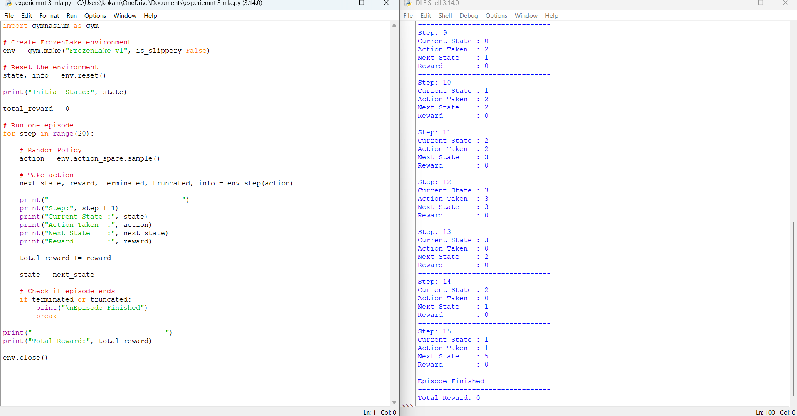

Experiment 4: Simulation of a Markov Decision Process (MDP)
Aim: To develop a simple Markov Decision Process model and simulate state
transitions, reward functions, and policy execution for understanding sequential
decision-making problems.
A. # Experiment 4
# Markov Decision Process (MDP)

# States
states = ["A", "B", "Goal"]

# Rewards for each state
rewards = {
"A": 0,
"B": 5,
"Goal": 10
}

# State Transition Table
transitions = {
"A": "B",
"B": "Goal",
"Goal": "Goal"
}

# Initial State
current_state = "A"

total_reward = 0

print("Markov Decision Process Simulation")
print("----------------------------------")

# Execute Policy
while current_state != "Goal":

print("Current State :", current_state)

# Policy: Move to the next state
next_state = transitions[current_state]

reward = rewards[next_state]

print("Next State :", next_state)
print("Reward :", reward)

total_reward += reward

current_state = next_state

print()

print("Final State :", current_state)
print("Total Reward :", total_reward)
OUTPUT;
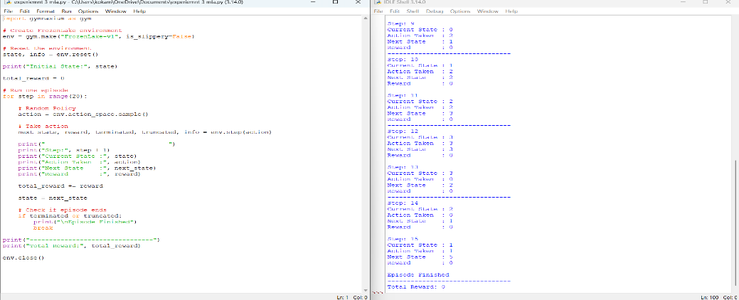

Experiment 5: Bellman Equation Demonstration
Aim: To implement Bellman Expectation and Bellman Optimality Equations for
calculating state-value and action-value functions and analyze the convergence of
value estimation.
A. # Experiment 5
# Bellman Expectation and Bellman Optimality Equation

# Discount Factor
gamma = 0.9

# Rewards for each state
rewards = {
"A": 5,
"B": 10,
"Goal": 20
}

# Initial State Values
V = {
"A": 0,
"B": 0,
"Goal": 0
}

# State Transitions
transitions = {
"A": "B",
"B": "Goal",
"Goal": "Goal"
}

print("Bellman Expectation Equation")
print("----------------------------")

# Bellman Expectation Iteration
for i in range(5):
new_V = {}

for state in V:
if state == "Goal":
new_V[state] = rewards[state]
else:
next_state = transitions[state]
new_V[state] = rewards[state] + gamma * V[next_state]

V = new_V

print(f"\nIteration {i+1}")
for state in V:
print(f"V({state}) = {V[state]:.2f}")

print("\n----------------------------")
print("Bellman Optimality Equation")
print("----------------------------")

Q = {}

for state in transitions:
next_state = transitions[state]
Q[state] = rewards[state] + gamma * V[next_state]

for state in Q:
print(f"Q({state}) = {Q[state]:.2f}")
OUTPUT;
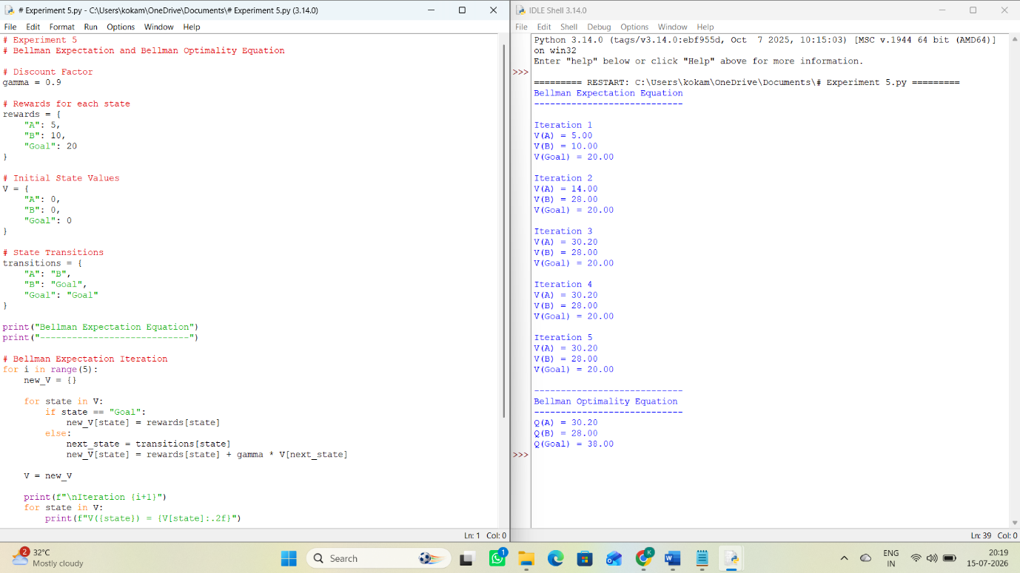

RUBRICS FOR CALCULATION
Criteria Weightage | Weightage | Level 4  (Exemplary) | Level 3  (Proficient) | Level 2  (Developing) | Level 1  (Beginning)
Understanding  of Concepts | 25% | Demonstrates thorough,  accurate  understanding of  concepts | Good  understanding  with minor  gaps | Basic  understanding  with some  misconceptions | Poor  understanding; major  misconceptions
Explanation | 25% | Detailed, well-  explained  answers with  relevant  examples | Clear  explanation  with adequate  details | Limited  explanation;  lacks depth | Poor or  unclear  explanation
Application | 20% | Effectively  applies concepts  with strong  analytical ability | Applies  concepts with  minor errors | Limited  application with  weak analysis | No  application or  incorrect  analysis
Organization | 15% | Well-structured  answers with  logical flow and  coherence | Organized with minor issues in flow | Basic structure,  lacks clarity | Poor  organization,  incoherent  answers
Accuracy | 10% | Completely  accurate and  covers all  required points | Mostly  accurate with  minor  omissions | Partially correct  with missing  points | Incorrect  answers with  major gaps
Clarity | 5% | Clear, neat,  professional  presentation | Understandable with minor  issues | Limited clarity,  readability issues | Poorly  written,  difficult to  understand

